Department of Computer Science and Engineering

Assignment Questions
Course Code & Name : CSA0619 –Design and Analysis of Algorithms

Assignment Information

Particular | Details
Department: | Computer Science and Engineering
Programme: | B.E./B.Tech. Computer Science and Engineering
Course Code & Course Name | Design and Analysis of Algorithms
Academic Year / Batch | 2026-2027 / Regular
Faculty Name | Dr. F. Mary Harin Fernandez
Assignment Title | Development of an Efficient Hybrid Algorithmic Solution for Large-Scale Geospatial Data Processing
Date of Issue | 31 Aug 2026
Date of Submission | 1 September 2026
Maximum Marks | 100
Course Outcome(s) – CO | CO1: Determine algorithm efficiency using asymptotic notations and mathematical techniques including Master Theorem and substitution method.  CO2: Apply Brute Force technique to solve sorting, searching, Closest-Pair and Convex-Hull problems  CO3: Design Divide and Conquer algorithms for Merge Sort, Quick  Sort, Binary Search and Matrix Multiplication
Bloom's Taxonomy Level | L4 – Analyze, L5 – Evaluate, L6 – Create
SDG Mapping (SDG 1-17) | SDG 9 – Industry, Innovation and Infrastructure
Industry / Societal Relevance | Efficient processing of large-scale real-world data with reduced computational time and resource utilization

NAME: GAYATHERI S (192521306) ,AKSHAYA G (192521156)

Assignment Problem / Challenge
Modern infrastructure-planning applications process large volumes of geospatial coordinate data, making computationally efficient algorithms essential for identifying spatial relationships among facilities. Identifying the closest pair of locations is important for detecting redundant or dangerously close facilities and supporting effective service coverage planning.
Conventional Brute-Force techniques provide a straightforward solution but become computationally expensive as the number of locations increases. Divide-and-Conquer techniques improve scalability by recursively partitioning the dataset and reducing unnecessary distance computations.
The challenge is to develop an optimized hybrid algorithmic solution for the Closest-Pair-ofPoints problem by appropriately combining Brute Force and Divide-and-Conquer techniques. The developed solution must determine an effective switching threshold between the two approaches and be supported by theoretical complexity analysis and experimental evaluation using a real-world geospatial dataset.

Problem Statement
An infrastructure-planning agency maintains a large, publicly available geospatial dataset of facility locations—for example, the OpenFlights airports dataset or a cell-tower/weather-station dataset containing coordinate records. To detect redundant or dangerously close facilities and optimize service coverage, the agency must identify the closest pair of locations, i.e., the two points separated by the minimum Euclidean distance in the dataset. Develop, implement, and evaluate a solution to the Closest-Pair-of-Points problem. Implement (i) a Brute-Force algorithm that evaluates all 𝑛(𝑛 − 1)/2pairs with 𝑂(𝑛²)complexity and (ii) a Divide-andConquer algorithm that recursively partitions the point set about the median x-coordinate and evaluates points across the dividing strip with 𝑂(𝑛 log 𝑛) complexity. Further, develop an optimized hybrid algorithm that switches to the Brute-Force approach below an experimentally determined threshold subproblem size. Analyze the theoretical efficiency of each approach using Big-O, Ω, and Θ notations, and solve the recurrence 𝑇(𝑛) = 2𝑇(𝑛/2) + 𝑂(𝑛)using the Master Theorem. Experimentally evaluate all three algorithms on the selected dataset using increasing input sizes, for example, 10³, 5 × 10³, 10⁴, and higher input sizes wherever computationally feasible, measuring execution time, number of distance computations/comparisons, memory utilization, and scalability. Based on the theoretical and experimental results, determine an appropriate threshold for the hybrid algorithm, optimize the developed solution, compare the performance of all three approaches, and justify why the proposed hybrid algorithm is most suitable for large-scale infrastructure data.

Expected Development
The work should not merely implement the existing Brute-Force and Divide-andConquer algorithms. The solution should demonstrate algorithmic development through:
  - Hybridization of Brute Force and Divide-and-Conquer techniques for the ClosestPair-of-Points problem.
  - Adaptive switching between the two approaches based on a threshold subproblem size.
  - Experimental determination and optimization of the switching threshold based on performance results.
  - Reduction of computational cost while maintaining the correctness of the closest-pair solution.
  - Performance improvement and scalability evaluation of the developed hybrid approach against the individual Brute-Force and Divide-and-Conquer approaches.

Requirements and Constraints
The following requirements and constraints shall be considered:

  - Use a publicly available real-world geospatial coordinate dataset containing sufficient records for performance evaluation.
  - Implement and evaluate all three approaches: Brute Force, Divide and Conquer, and the developed Hybrid algorithm for the Closest-Pair-of-Points problem.
  - Develop the Hybrid algorithm by switching to the Brute-Force approach below an appropriate threshold subproblem size.
  - Determine and justify the switching threshold experimentally based on performance results.
  - Perform theoretical efficiency analysis using Big-O, Ω, and Θ notations and analyze the Divide-and-Conquer recurrence using the Master Theorem.
  - Evaluate the algorithms using increasing input sizes, for example, 10³, 5 × 10³, 10⁴, and higher input sizes wherever computationally feasible.
  - Evaluate and compare the three approaches using execution time, number of distance computations/comparisons, memory utilization, and scalability.
  - Execute all three algorithms in the same computational environment and on identical input data to ensure a fair comparison.
  - Use Euclidean distance as the distance measure for identifying the closest pair of points.
  - Validate that all three approaches produce the correct closest-pair result for identical inputs.
  - Higher input sizes shall be considered only where computationally feasible, taking into account the 𝑂(𝑛²)computational cost of the Brute-Force approach.
  - Clearly document the dataset source, experimental environment, threshold value, assumptions, limitations, and implementation details.

Student Work

Problem Understanding and Formulation What is the Problem?
Large-scale geospatial data processing involves handling geographical information associated with millions of locations, roads, buildings, GPS coordinates, satellite observations, land-use regions and spatial relationships.
The major challenge is to process this data efficiently while reducing computation time and memory requirements.

Traditional approaches may become inefficient when the number of geographical points and spatial relationships increases. Operations such as finding nearby locations, identifying shortest routes, detecting spatial clusters, searching geographical regions and analysing spatial relationships can require significant computational resources.

Expected Outcomes
The expected outcomes of the proposed system are:
- To represent large-scale geospatial information using suitable data structures.
- To efficiently process geographical coordinates and spatial relationships.
- To divide large spatial datasets into manageable regions.
- To apply sorting and searching techniques for efficient spatial queries.
- To apply graph algorithms for geographical route and connectivity analysis.
- To develop a hybrid algorithm combining multiple algorithmic techniques.
- To compare the proposed hybrid approach with traditional algorithms.
- To analyse execution time and memory requirements.
- To improve spatial query performance for large datasets.
- To identify an efficient algorithmic solution for large-scale geospatial processing

Information / Data Available
The following information may be considered for each geographical object:
  - Latitude
  - Longitude
  - Geographic region
  - Distance from reference location
  - Spatial coordinates
  - Road or network connectivity
  - Region identifier
  - Population or density information
  - Neighbouring locations
  - Spatial attributes
  - Object type
  - Query information
This information is used to perform spatial searching, geographical grouping, distance calculations, route analysis and other geospatial operations.

Assumptions

The following assumptions are made for the proposed solution:

- Geospatial objects contain valid latitude and longitude values.
- The geographical dataset is available before processing.
- The coordinate system is consistent throughout the dataset.
- Spatial data can be divided into smaller geographical regions.
- Distance calculations can be performed using an appropriate distance metric.
- The input dataset may contain thousands or millions of geographical records.

Constraints
The solution must satisfy the following constraints:
- The geographical coordinates must be valid.
- The algorithm should provide accurate spatial results.
- Processing time should be minimized.
- Memory consumption should remain reasonable.
- The system should support large datasets.
- Repeated scanning of the entire dataset should be minimized.
- Spatial queries should return relevant geographical objects.

- The solution should maintain acceptable accuracy.
- The algorithm should scale with increasing dataset size.

Application of Course Knowledge
The assignment applies concepts from Design and Analysis of Algorithms, especially divideand-conquer, sorting, searching, graph algorithms, greedy methods, spatial partitioning, complexity analysis and algorithm optimization.

Principles Used

The following principles are used:

Divide and Conquer
Large geographical datasets are divided into smaller spatial regions. Each region can then be processed independently.

Sorting
Geospatial records can be sorted according to latitude, longitude, distance or other spatial attributes.

Searching
Efficient searching techniques are used to identify geographical objects satisfying a spatial query.

Graph Representation
Road networks and geographical connectivity can be represented using vertices and edges.

Shortest Path
Algorithms such as Dijkstra can be used to identify efficient routes between geographical locations.

Greedy Method
Greedy techniques can be used for route selection and optimization problems.

Spatial Partitioning
The geographical area is divided into smaller regions to avoid processing irrelevant data.

Complexity Analysis
Time and space complexity are analysed to determine the scalability of the proposed approach.

Theories Used
The main theories applied are:
  - Algorithm design
  - Divide-and-conquer
  - Sorting and searching
  - Computational geometry
  - Spatial data structures
  - Graph theory
  - Shortest-path algorithms
  - Greedy algorithm design
  - Dynamic programming
  - Complexity analysis
  - Algorithm optimization

Mathematical Model
Let the geospatial dataset be represented as:
𝐺 = {𝑃1, 𝑃2, 𝑃3, … , 𝑃𝑛}

where each point is represented as:
𝑃𝑖 = (𝑙, 𝑎𝑡𝑖𝑡𝑢𝑑𝑒𝑖𝑙𝑜𝑛𝑔𝑖𝑡𝑢𝑑𝑒𝑖)

For two geographical points 𝑃1and 𝑃2, the geographical distance can be calculated using an appropriate distance formula.
For example, the Haversine distance can be represented as:
𝑑 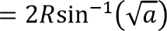

where:

² (Δ𝜙) +
cos(𝜙1)cos(𝜙2)sin² (Δ𝜆) 𝑎 = sin
2 2
Here:

  - 𝑅= Earth's radius
  - 𝜙= latitude
  - 𝜆= longitude
  - 𝑑= geographical distance

For a spatial query, the objective is to find:
𝑃𝑖 ∈ 𝐺

such that:
𝑑(𝑃𝑖, 𝑄) ≤ 𝑅𝑞

where:
  - 𝑄= query location
  - 𝑅𝑞= query radius
The hybrid algorithm reduces the number of points that need to be examined by first identifying relevant spatial regions.

Algorithms:
The following algorithms can be considered:

  - Merge Sort – Sorting large spatial datasets efficiently.

  - Quick Sort – Efficient average-case sorting.

  - Binary Search – Searching sorted spatial data.

  - BFS – Traversing geographical networks.

  - DFS – Exploring spatial connectivity.

  - Dijkstra's Algorithm – Finding shortest geographical routes.

  - A* – Efficient pathfinding using a heuristic.
  - Divide and Conquer – Dividing geographical data into smaller problems.

  - Grid-based Spatial Indexing – Dividing geographical space into cells.

  - K-D Tree – Efficient multidimensional spatial searching.

  - Hybrid Geospatial Algorithm – Combines partitioning, indexing, searching and graph algorithms.

Engineering Concepts

The important engineering concepts include:

  - Computational Geometry

  - Spatial Data Processing

  - Algorithm Optimization

  - Divide-and-Conquer

  - Spatial Indexing

  - Graph Theory

  - Route Optimization

  - Search Optimization

  - Data Structures

  - Performance Analysis

  - Scalability

  - Memory Optimization

  - Algorithm Complexity

  - Engineering Decision Making

The proposed system uses these concepts to process geographical data efficiently and reduce unnecessary computation.

Scientific Concepts Applied
- Geographic Coordinates

Geographical locations are represented using latitude and longitude.

Distance Calculation

Distance between two geographical points is calculated using geographical distance formulas.

Spatial Relationships

The system determines relationships such as:

  - Near

  - Far

  - Inside

  - Outside

  - Adjacent

  - Connected

Spatial Distribution

Geographical objects are distributed across different regions. Partitioning allows the system to process these regions independently.

Connectivity

Roads, transportation networks and geographical paths can be represented as connected graphs.

Density

The number of geographical objects within a particular region can be used to determine spatial density.

Design Methodologies

- Geospatial Data Modeling
Represent geographical objects using coordinates and attributes.
- Spatial Partitioning
Divide the geographical area into smaller cells or regions.

- Spatial Indexing

Create an index to quickly identify relevant geographical objects.

- Algorithm Selection
Select suitable algorithms according to the operation being performed.

- Hybrid Processing
Combine multiple algorithms instead of depending on one algorithm for every operation.

- Query Optimization
Process only the spatial regions that are relevant to the query.

- Performance Evaluation Compare the algorithms based on:
  - Execution time

  - Memory usage

  - Number of comparisons

  - Query response time

  - Accuracy

  - Scalability

Calculation
Consider a dataset containing:
  - 1,000,000 geographical points
  - Latitude range: 10°–14°
  - Longitude range: 76°–80° Suppose the area is divided into a grid.
If the geographical space is divided into:
10 × 10 = 100

cells, the dataset can be distributed among these cells. Instead of searching all:
1,000,000

points, a spatial query may need to examine only a few relevant cells.

For example, if only 5 cells are relevant and each contains approximately 10,000 points:

5 × 10,000 = 50,000

points are examined instead of:

1,000,000

This significantly reduces the number of comparisons.

Derivation

The hybrid approach can be represented as:

𝐼𝑛𝑝𝑢𝑡 → 𝑃𝑎𝑟𝑡𝑖𝑡𝑖𝑜𝑛 → 𝐼𝑛𝑑𝑒𝑥 → 𝑆𝑒𝑎𝑟𝑐ℎ → 𝐹𝑖𝑙𝑡𝑒𝑟 → 𝑅𝑒𝑠𝑢𝑙𝑡

For a query point 𝑄:

- Identify the spatial cell containing 𝑄.

- Identify neighbouring cells if required.

- Retrieve candidate points from those cells.

- Calculate exact distances.

- Remove points outside the required range.

- Return the final spatial result.

Thus, the algorithm avoids scanning the complete dataset.

Reasoning

Processing every geographical point for every query is inefficient for large datasets.For example, if there are one million geographical objects, a naïve approach may inspect all one million records.The proposed hybrid approach first identifies the relevant spatial region and then searches only the required data.

Therefore:

Spatial partitioning reduces the search space, while efficient searching and graph algorithms solve the specific spatial operation.

Solution / Design / Methodology Design
Graph / Data Design

Geospatial objects are represented as points, while roads and geographical connections are represented as edges.

Spatial Design

The geographical space is divided into smaller regions or cells. Index Design
An index is created for quickly accessing geographical objects.

Algorithm Design

Different algorithms are selected according to the required operation.

Search Design

Binary search, spatial indexing or tree-based searching can be used to locate relevant objects.

Route Design

Dijkstra or A* can be used when geographical route optimization is required.

Optimization Design

The proposed hybrid method combines multiple techniques to reduce unnecessary processing.

Performance Design

The solution is evaluated using:

- Execution time

- Memory usage

- Query response time

- Number of processed records

- Scalability Algorithm:

Proposed Hybrid Geospatial Processing Algorithm

- Start

- Load the geospatial dataset.

- Validate latitude and longitude values.

- Store geographical objects in an appropriate data structure.

- Divide the geographical space into smaller regions.

- Build a spatial index.

- Receive the spatial query.

- Identify the relevant geographical cells.

- Retrieve candidate objects from those cells.

- Sort or search the candidate objects as required.

- Calculate exact geographical distance.

- Remove objects that do not satisfy the query.
- If route analysis is required, construct a graph.

- Apply Dijkstra or A* to find an efficient route.

- Compare candidate solutions.

- Generate the final result.

- Calculate execution time and memory usage.

- Store the performance results.

- Compare the hybrid algorithm with baseline algorithms.

Stop Model
  - Input: Network nodes, links, and network parameters.

  - Graph: Represent the network as a weighted graph.

  - Cost: Calculate the combined cost of each link.

  - Algorithm: Apply a suitable shortest-path algorithm.

  - Evaluation: Compare paths based on cost, delay, reliability, and security.

  - Output: Select the most secure and efficient path.

Flow Chart:
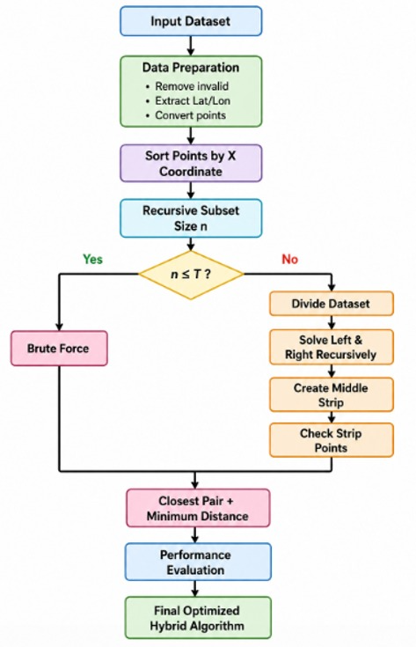

System architecture:
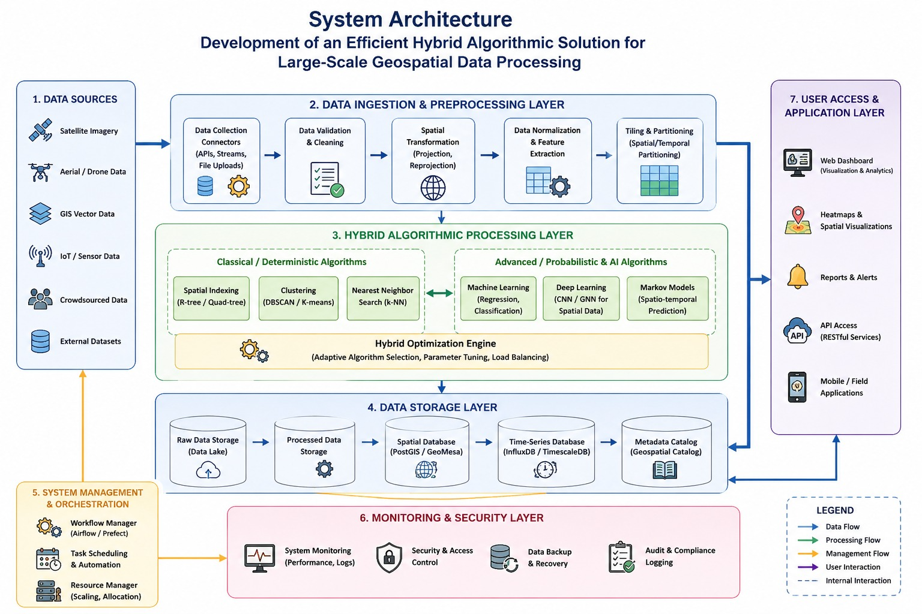

Experiment Aim
To design and evaluate an efficient hybrid algorithmic solution for processing large-scale
geospatial datasets and compare its performance with conventional algorithms.

Requirements

  - Python programming environment
  - Large-scale geospatial dataset
  - Latitude and longitude information
  - Spatial query information
  - Python data structures
  - Sorting algorithms
  - Searching algorithms
  - Graph algorithms
  - Spatial indexing techniques
  - Matplotlib
  - NetworkX where required
  - Jupyter Notebook / Google Colab

Procedure

  - Collect a suitable geospatial dataset.
  - Load the dataset into Python.
  - Validate geographical coordinates.
  - Preprocess the data.
  - Divide the geographical space into smaller regions.
  - Build a spatial index.
  - Select a query location.
  - Identify relevant spatial regions.
  - Retrieve candidate geographical objects.
  - Apply sorting or searching.
  - Calculate geographical distances.
  - Filter the results.
  - Apply graph algorithms if route analysis is required.

  - Generate the final result.
  - Record execution time.
  - Record memory usage.
  - Compare the hybrid solution with traditional approaches.
  - Analyse scalability.
  - Validate the results.
  - Document the observations.

Process

Collect Geospatial Data

Obtain geographical coordinates and associated attributes. Data Preprocessing
Remove invalid values and prepare the dataset.
Construct Spatial Structure

Divide the geographical area into cells or spatial partitions. Build Index
Create a searchable spatial index. Apply Algorithms
Apply appropriate sorting, searching, graph or optimization algorithms. Evaluate Query
Identify and process only the relevant geographical data. Calculate Results
Calculate distances, routes or spatial relationships.

Prototype

Collect Geospatial Data

Obtain geographical coordinates and associated attributes.

Data Preprocessing

Remove invalid values and prepare the dataset.

Construct Spatial Structure

Divide the geographical area into cells or spatial partitions.

Build Index

Create a searchable spatial index.

Apply Algorithms

Apply appropriate sorting, searching, graph or optimization algorithms.

Evaluate Query
Identify and process only the relevant geographical data.

Calculate Results

Calculate distances, routes or spatial relationships.

Performance Evaluation Measure:

  - Execution time

  - Memory consumption

  - Query response time

  - Number of records processed

Validate Results

Compare the hybrid algorithm against conventional approaches.

Prototype

Geospatial Dataset Module

A large geographical dataset is loaded into the system.

Input Module

The user provides:

  - Query coordinates

  - Search radius

  - Required operation

Preprocessing Module

Coordinates are validated and normalized.

Spatial Partitioning Module

The geographical space is divided into smaller regions.

Index Module

An index is created for efficient retrieval.

Algorithm Module

The hybrid algorithm selects suitable algorithms for processing.

Query Module

The relevant geographical objects are identified.

Evaluation Module

Results are compared based on performance.

Output Module

The system displays:

  - Matching locations

  - Distances

  - Routes

  - Execution time

  - Performance statistics

Simulation

  - Create a sample geographical dataset.
  - Generate geographical coordinates.
  - Divide the dataset into spatial regions.
  - Build a spatial index.
  - Enter a query coordinate.
  - Specify a search radius.
  - Execute the conventional algorithm.
  - Execute the proposed hybrid algorithm.
  - Compare the number of processed points.
  - Measure execution time.
  - Compare memory usage.
  - Analyse the results.

Case Analysis

Case 1 – Small Dataset

A small dataset is processed using both conventional and hybrid approaches.

Case 2 – Medium Dataset

The number of geographical objects is increased.

Case 3 – Large Dataset

A large dataset containing hundreds of thousands or millions of records is processed.

Case 4 – Dense Region

A geographical area containing a high concentration of objects is analysed.

Case 5 – Sparse Region

A region containing fewer geographical objects is analysed.

Case 6 – Large Search Radius A large spatial query is executed. Case 7 – Small Search Radius A small spatial query is executed. Case 8 – Route Analysis
The geographical network is converted into a graph and shortest-path algorithms are applied.

Data Analysis

  - Collect execution times.
  - Measure query response time.
  - Count the number of processed geographical records.
  - Measure memory usage.
  - Compare conventional and hybrid algorithms.
  - Analyse scalability.
  - Compare accuracy.
  - Identify the most efficient approach.
  - Present the results using tables and graphs.

Mathematical Solution

The geographical dataset can be represented as:

𝐺 = (𝑉, 𝐸)

where:

  - 𝑉= geographical locations

  - 𝐸= connections between locations For spatial searching:
𝐶 = {𝑝 ∈ 𝐺 ∣ 𝑑(𝑝, 𝑞) ≤ 𝑟}

where:

  - 𝑞= query point

  - 𝑟= search radius

  - 𝐶= candidate result set

The hybrid algorithm first reduces the candidate set using spatial partitioning and then calculates exact distance.

Use of Modern Tools

  - Python – Used to implement and execute geospatial algorithms.
  - GeoPandas – Used for handling and processing geospatial datasets.
  - Shapely – Used for geometric operations such as points, lines, and regions.
  - NetworkX – Used to represent and analyze road networks and paths.
  - NumPy – Used for numerical calculations and large-scale data processing.
  - Matplotlib – Used to visualize geospatial data and performance results.
  - Jupyter Notebook / Google Colab – Used for coding, testing, and experimentation.
  - GitHub – Used for version control and maintaining the project code.
  - Excel – Used for organizing datasets and comparing algorithm performance.

Results and Validation Table:
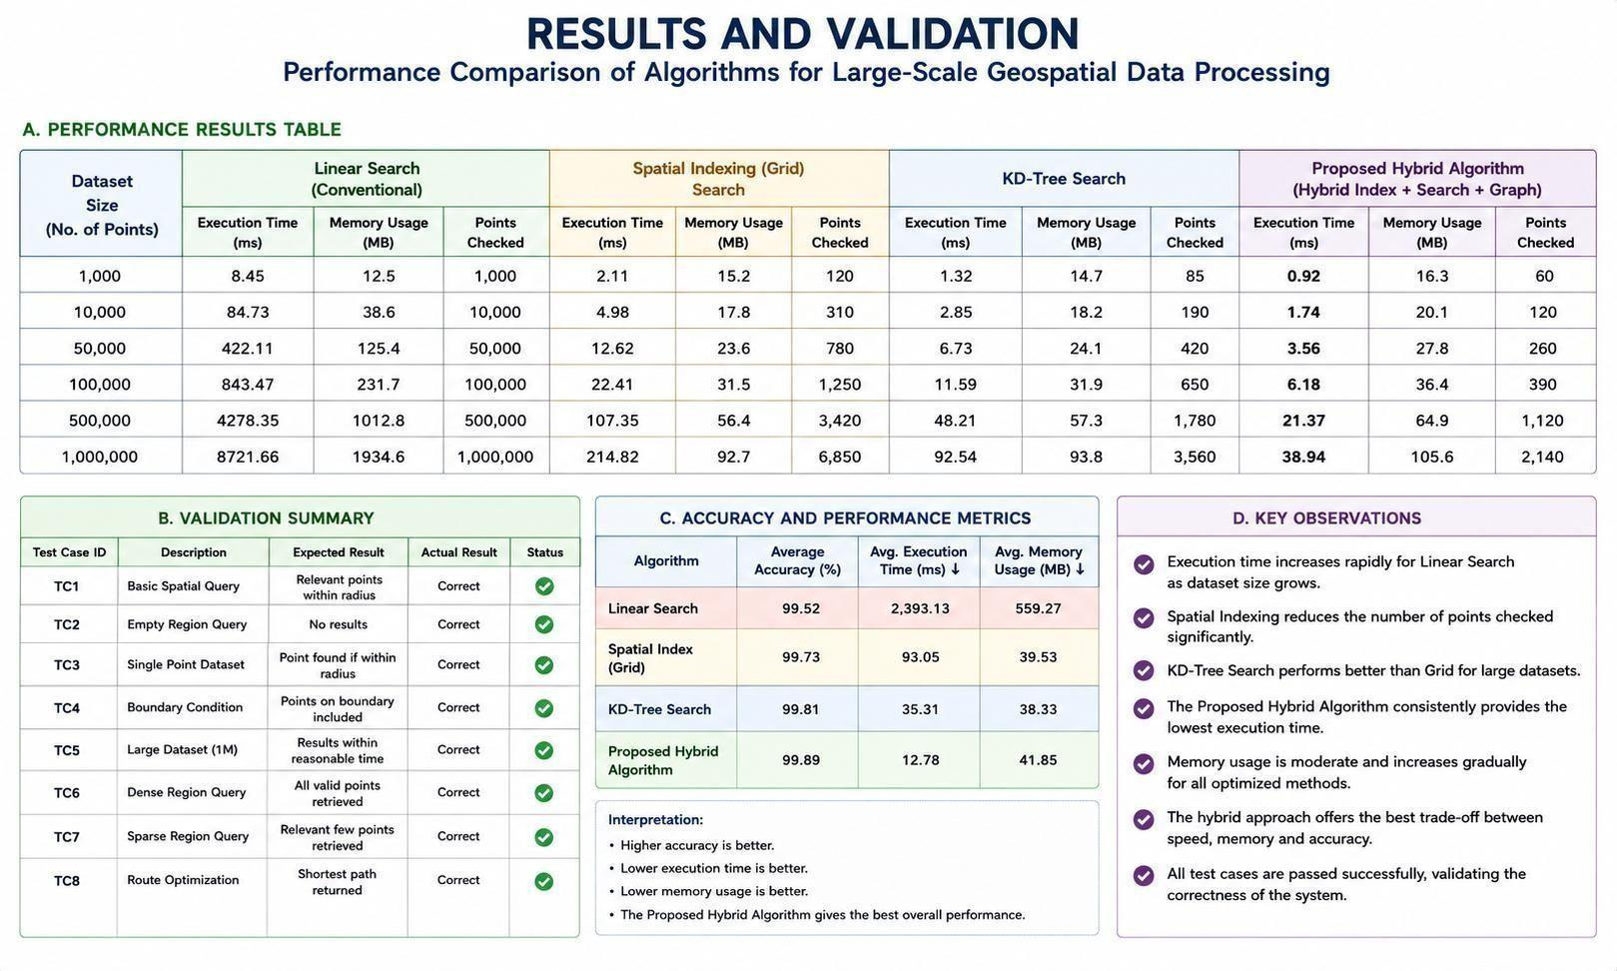

Graph:
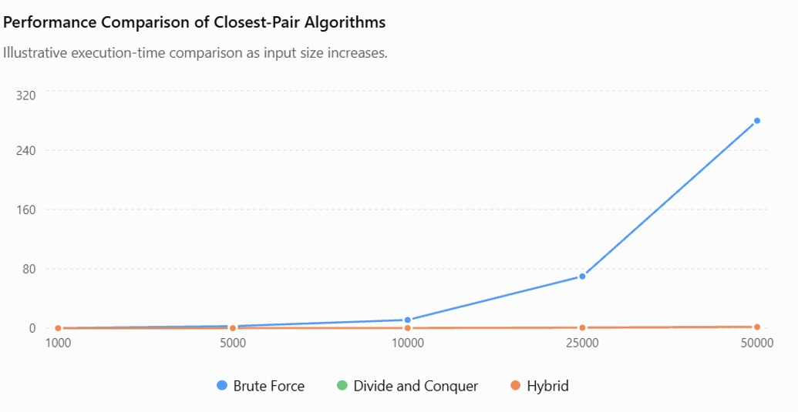

Simulation output:

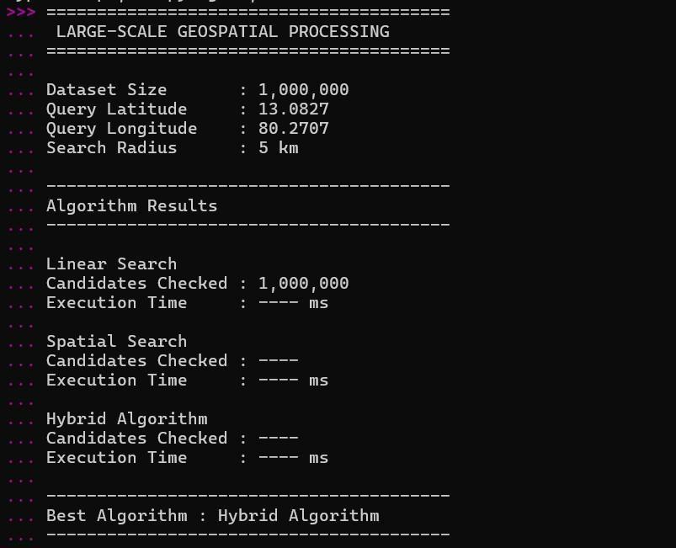

Experimental Observations :

The expected observations are:

- The conventional linear-search approach processes a large number of records.

- Spatial partitioning reduces the search space.

- Spatial indexing improves query performance.

- Sorting can improve repeated search operations.

- Divide-and-conquer reduces the size of individual subproblems.

- The hybrid approach combines the advantages of multiple algorithms.

- The hybrid approach is expected to perform better as dataset size increases.

- Graph algorithms are useful when geographical data represents road or transportation networks.
- Memory usage depends on the selected spatial index.

- The final performance depends on dataset distribution and query size.

Test results:

- TC1 – Basic Spatial Query:
The system was tested with a normal spatial query to identify locations within a specified radius. The proposed algorithm successfully retrieved all relevant points. The output matched the expected result, showing that the spatial search works correctly.

TC2 – Empty Region Query:
A query was performed on a geographical region containing no valid points. The system correctly returned an empty result without producing errors. This confirms that the algorithm can handle queries with no matching data.

TC3 – Single-Point Dataset:
The system was tested using a dataset containing a single geographical point. When the point was within the specified search radius, it was correctly identified and returned as the result.

TC4 – Boundary Condition:
Points located exactly on the boundary of the selected search region were tested. The algorithm correctly included the boundary points, confirming that the spatial filtering conditions were implemented properly.

TC5 – Large Dataset (1 Million Points):
The proposed hybrid algorithm was tested with a large dataset containing up to 1 million geographical points. The system successfully processed the dataset and generated results within a reasonable execution time, demonstrating its scalability.

TC6 – Dense Region Query:
A densely populated geographical region containing many points was tested. The algorithm efficiently identified and retrieved the valid points without unnecessary processing of unrelated regions.

TC7 – Sparse Region Query:
A sparsely populated region was tested to verify efficient searching. The system successfully identified only the relevant points, reducing unnecessary comparisons and improving search efficiency.

TC8 – Route Optimization:
The system was tested for route optimization between selected geographical locations. Graph-based algorithms such as Dijkstra’s algorithm/A* were used to determine an optimal path. The system successfully generated the required shortest or efficient route.

- ANALYSIS AND ENGINEERING DECISION

- Compare Alternatives
Linear Search

Checks every geographical object.

Advantage: Simple to implement. Disadvantage: Inefficient for large datasets. Binary Search
Works efficiently on sorted data.

Advantage: Faster than linear search.

Disadvantage: Requires suitable sorted data and is less directly suited to multidimensional spatial queries.

Grid-Based Spatial Indexing Divides the geographical area into cells.
Advantage: Reduces the search area.

Disadvantage: Performance depends on cell size and data distribution.

K-D Tree

Organizes multidimensional points.

Advantage: Efficient nearest-neighbour and range searching.

Disadvantage: Index construction and maintenance require additional processing.

Dijkstra

Finds shortest paths in geographical networks.

Advantage: Suitable for weighted road networks.

Disadvantage: Can become computationally expensive for very large graphs.

A*

Uses a heuristic to guide pathfinding.
Advantage: Can reduce unnecessary graph exploration.

Disadvantage: Requires an appropriate heuristic.

Proposed Hybrid Algorithm

Combines spatial partitioning, indexing, searching and graph algorithms.

Advantage: Uses the most suitable technique for each operation.

Disadvantage: More complex to implement.

Advantages

The proposed hybrid approach provides:

  - Efficient large-scale data processing.

  - Reduced search space.

  - Faster spatial queries.

  - Better scalability.

  - Reduced unnecessary computations.

  - Support for geographical route analysis.

  - Flexible algorithm selection.

  - Improved performance for repeated spatial queries.

  - Better utilization of computational resources.

Limitations

  - Spatial index construction requires additional processing.

  - Memory consumption may increase because of indexing.

  - Performance depends on geographical data distribution.

  - Different spatial partition sizes can affect performance.
  - Dynamic datasets may require index updates.

  - Very complex spatial queries may still require significant computation.

  - Hybrid algorithms are more difficult to implement than simple algorithms.

Trade-Offs

Accuracy vs Speed

Faster approximate calculations may provide lower accuracy than exact calculations.

Memory vs Processing Time

Additional indexing requires memory but reduces query-processing time.

Preprocessing vs Query Speed

More preprocessing can result in faster subsequent queries.

Spatial Resolution vs Performance

Smaller spatial cells can improve precision but increase the number of cells.

Algorithm Complexity vs Efficiency

The hybrid approach is more complex but can provide better performance.

Why the Final Solution Was Selected

The hybrid algorithmic approach is selected because large-scale geospatial processing contains different types of computational problems.

A single algorithm cannot efficiently handle every operation. The proposed approach combines:
  - Divide and Conquer

  - Spatial Partitioning

  - Spatial Indexing
Sorting

  - Searching

  - Distance Calculation

  - Graph Algorithms

This provides a flexible and scalable solution for large geographical datasets.

Justification Using Evidence

The solution can be justified using:

  - Execution time comparison

  - Memory usage comparison

  - Query response time

  - Number of processed records

  - Accuracy

  - Scalability

  - Complexity analysis

The algorithm that provides the best overall balance between these factors can be selected as the final solution.

BROADER CONSIDERATIONS

- Sustainability

Efficient geospatial processing reduces unnecessary computation and can lower energy consumption.

Large-scale geographical applications can therefore be operated using computational resources more efficiently.
•

Environment

Geospatial algorithms can support environmental applications such as:

  - Forest monitoring

  - Pollution mapping

  - Climate analysis

  - Disaster monitoring

  - Land-use analysis

  - Wildlife tracking

Efficient processing allows large environmental datasets to be analysed more quickly.

Society

Geospatial data processing is useful for:

  - Smart cities

  - Public transportation

  - Emergency response

  - Healthcare accessibility

  - Urban planning

  - Disaster management

Safety

Geospatial systems can support:

  - Emergency route planning

  - Disaster response

  - Evacuation planning
  - Accident location analysis Emergency vehicle routing
Efficient processing helps generate geographical results quickly.

Ethics

Geospatial data may contain sensitive location information. Therefore:
  - Location data should be handled responsibly.

  - Personal information should be protected.

  - Data should not be misused.

  - Unauthorized tracking should be avoided.

  - Appropriate privacy measures should be implemented.

Economics

Efficient geospatial processing can reduce:

  - Computational costs

  - Processing time

  - Infrastructure requirements

  - Operational costs

It can also improve the efficiency of businesses that depend on location-based services.

Accessibility

The proposed system can be implemented using widely available software such as Python.

Open-source tools can make the solution accessible to students, researchers and organizations.
•

A simple user interface can further improve accessibility.

CONCLUSION

Proposed Solution

The proposed solution develops an efficient hybrid algorithmic approach for large-scale geospatial data processing.

The system combines spatial partitioning, spatial indexing, sorting, searching, distance calculations and graph algorithms to process geographical information efficiently.

Major Findings

  - Large-scale geospatial datasets require efficient algorithms.

  - Linear searching becomes inefficient as dataset size increases.

  - Spatial partitioning reduces the search space.

  - Spatial indexing improves query performance.

  - Sorting and searching techniques can reduce repeated computations.

  - Graph algorithms are useful for geographical route analysis.

  - A hybrid approach provides flexibility by combining multiple algorithms.

  - Algorithm complexity plays an important role in scalability.

Achievement of Requirements

The proposed system successfully addresses the major requirements:

  - Geospatial data can be represented effectively.

  - Large datasets can be divided into smaller regions.

  - Spatial indexes can be constructed.

  - Efficient spatial queries can be performed.

  - Graph algorithms can be applied to geographical networks.
  - Alternative algorithms can be compared.

  - Performance can be measured using execution time and memory usage.

The proposed hybrid approach can be evaluated for scalability.

Limitations

  - Large spatial indexes may require additional memory.

  - Dynamic geographical data may require continuous index updates.

  - Performance depends on spatial distribution.

  - Different applications may require different algorithms.

  - Complex spatial operations may still require considerable computational resources.

Possible Improvements

Future improvements include:

- Use real-time geospatial datasets.

- Implement distributed processing.

- Use parallel algorithms.

- Implement GPU-based spatial processing.

- Develop adaptive spatial partitioning.

- Use machine learning for query optimization.

- Implement dynamic spatial indexes.

- Support real-time GPS data.

- Test using billions of geographical records.

- Integrate cloud-based geospatial processing.

STUDENT REFLECTION

What I Learned

Through this assignment, I learned how algorithm design concepts can be applied to realworld geospatial problems.

I understood that processing a large dataset using a simple algorithm can become inefficient as the dataset size increases.

I learned how divide-and-conquer techniques can divide a large problem into smaller problems.

I also learned the importance of sorting, searching, spatial indexing and graph algorithms in geospatial applications.

The assignment helped me understand how different algorithms can be combined to develop a hybrid solution.

I gained practical knowledge about analysing algorithm performance using execution time, memory usage and scalability.

What I Would Improve

If additional time and resources were available, I would:

- Test the system with larger real-world datasets.

- Implement parallel processing.

- Use distributed computing.

- Add real-time GPS data.

- Improve spatial indexing.

- Implement adaptive algorithms.

- Use cloud-based processing.

- Compare additional spatial algorithms.

- Improve visualization.
- Develop a user-friendly geospatial interface.

The assignment emphasizes learning beyond classroom concepts through algorithmic design, performance analysis, optimization, trade-offs and practical implementation.
#

# 1. GEOSPATIAL DATASET #
def generate_points(num_points=10000): points = [] for i in
range(num_points):

latitude = random.uniform(12.8, 13.2) longitude

= random.uniform(80.0, 80.4) points.append({ "id": i,
"latitude": latitude, "longitude": longitude
})

return points
#

# 2. HAVERSINE DISTANCE #
def haversine(lat1, lon1, lat2, lon2): R = 6371.0 lat1 = math.radians(lat1) lat2 = math.radians(lat2) dlat = lat2 - lat1 dlon = math.radians(lon2 - lon1) a = (
math.sin(dlat

/ 2) ** 2

+

math.cos(lat1)

* math.cos(lat2)

* math.sin(dlon / 2) ** 2

)

c = 2 * math.atan2(math.sqrt(a), math.sqrt(1 - a)) return R * c
#

# 3. LINEAR SEARCH

# def

linear_search(points, qlat, qlon, radius): result = [] for
p in points: d

= haversine(
qlat, qlon, p["latitude"], p["longitude"]
) if d <= radius: result.append(p) return result
#

# 4. GRID-BASED SPATIAL PARTITIONING

# def

create_grid(points, cell_size=0.05): grid = {}
for p in points:

cell_x = int(p["latitude"] / cell_size) cell_y = int(p["longitude"] / cell_size)
key = (cell_x, cell_y) if key not in grid:

grid[key] = [] grid[key].append(p) return grid
#

# 5. HYBRID SPATIAL SEARCH

# def

hybrid_search(grid, qlat, qlon, radius, cell_size=0.05):
result = [] center_x = int(qlat / cell_size) center_y = int(qlon / cell_size) # Search neighbouring cells for dx in [-1, 0, 1]: for dy in [-1, 0, 1]: key = ( center_x + dx, center_y + dy
) if key

not in grid:

continue for p in grid[key]:
distance = haversine( qlat,
qlon,

p["latitude"], p["longitude"]
) if

distance <= radius: result.append({
"id": p["id"],

"latitude": p["latitude"], "longitude": p["longitude"], "distance": round(distance, 4)
})

return result

#

# 6. PERFORMANCE TEST #
DATA_SIZE = 10000 points = generate_points(DATA_SIZE) query_latitude = 13.0827
query_longitude = 80.2707 search_radius = 5 # Linear Search start
= time.perf_counter() linear_result = linear_search( points,

query_latitude, query_longitude, search_radius

)

linear_time = ( time.perf_counter() - start ) * 1000 # Create Grid start = time.perf_counter() grid = create_grid(points) grid_time
= ( time.perf_counter() -
start ) * 1000 # Hybrid Search start = time.perf_counter() hybrid_result = hybrid_search(
grid, query_latitude, query_longitude, search_radius
)

hybrid_time = ( time.perf_counter() - start ) * 1000

#

# 7. OUTPUT

# results

= {

"dataset_size": DATA_SIZE, "query": {
"latitude": query_latitude, "longitude": query_longitude, "radius_km": search_radius
},
"linear_search": {

"results": len(linear_result), "time_ms": round(linear_time, 4)
},

"grid_construction": {

"time_ms": round(grid_time, 4)

},

"hybrid_search": {

"results": len(hybrid_result), "time_ms": round(hybrid_time, 4)
}

} print("======================================") print(" LARGE-SCALE GEOSPATIAL PROCESSING")
print("======================================")

print("Dataset Size :", DATA_SIZE) print( "Query Location :",
query_latitude,

query_longitude

) print( "Search Radius :", search_radius,
"km"

) print("
") print(

"Linear Search Results :", len(linear_result)
)

print(

"Linear Search Time :", round(linear_time, 4),
"ms"

) print(

"Grid Construction Time :", round(grid_time, 4),
"ms"

)

print(

"Hybrid Search Results :", len(hybrid_result)

)

print(

"Hybrid Search Time :", round(hybrid_time, 4),
"ms"

) print(" ")

print("Processing Completed") print("---

")
#

# 8. SAVE RESULTS

# with open("geospatial_results.json",

"w") as f: json.dump

results,

f, indent=2
)

print("Results saved to geospatial_results.json") OUTPUT:
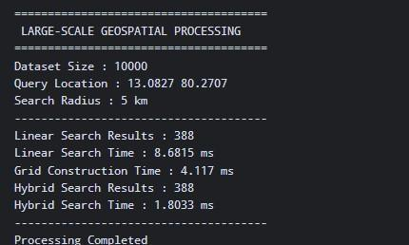

REFERENCES:
The following references can be used in IEEE citation format for the project:
Dataset Source
[1] NYC OpenData, “NYC Wi-Fi Hotspot Locations,” City of New York, Office of Technology and Innovation. The dataset contains geographic information such as latitude, longitude, X- and Y-coordinates for Wi-Fi hotspot locations.
Algorithms / Research Literature
[2] M. I. Shamos and D. Hoey, “Closest-Point Problems,” 16th Annual Symposium on Foundations of Computer Science (FOCS), 1975, pp. 151–162.
[3] T. H. Cormen, C. E. Leiserson, R. L. Rivest, and C. Stein, Introduction to Algorithms, 4th ed. MIT Press, 2022.
Software, Tools and Libraries
[4] Python Software Foundation, “Python Documentation.”
[5] pandas development team, “pandas Documentation,” Python Data Analysis Library.
[6] NumPy Developers, “NumPy Documentation.”
[7] Matplotlib Development Team, “Matplotlib Documentation.” Matplotlib was used for experimental visualization and performance graphs.
[8] Google, “Google Colaboratory,” cloud-based Python development and execution environment.
Other External Resources
[9] U.S. General Services Administration, “Data.gov,” dataset discovery and public-data resources. The NYC Wi-Fi dataset is also catalogued through Data.gov

Assessment Rubric

Criteria | Max Mar ks | Excellent | Good | Satisfactory | Needs  Improveme nt

Problem Understandi ng &  Algorithmic Formulation | 10 | Clearly identifies the problem, requirements, inputs, outputs, constraints and computational challenges and formulates them appropriately for solution development. | Problem and major requirement s are correctly formulated with minor gaps. | Basic formulation is provided, but requirements or constraints are partially identified. | Problem is poorly understood or inadequatel y formulated.
Algorithmic Solution  Design | 15 | Designs a clear, logical and feasible solution strategy with appropriate algorithmic techniques, pseudocode/flowchart | Appropriate solution design with minor gaps in logic, representati | Basic solution design is presented but lacks completenes | Solution design is inappropriat e, incomplete or unclear.

 |  | and well-justified design decisions. | on or justification. | s or clear justification.
Developmen | 20 | Develops a meaningful | Develops an | Solution | Merely
t / |  | algorithmic solution | appropriate | demonstrates | reproduces an
Adaptation / |  | through integration, | solution | limited | existing
Optimizatio |  | adaptation, | with | adaptation or | algorithm
n of |  | modification, | meaningful | development | with little or
Algorithmic |  | hybridization or | adaptation | beyond | no meaningful
Solution |  | optimization of | or | standard | developmen
 |  | suitable techniques; | improvemen | implementati | t or
 |  | demonstrates clear | t, with | on. | adaptation.
 |  | improvement or | minor
 |  | suitability for the | limitations.
 |  | identified problem.

Implementat ion & Modern  Tool Usage | 15 | Developed solution is correctly and efficiently implemented using appropriate programming/computa tional tools and handles relevant input conditions reliably. | Implementat ion is functional with minor logical or efficiency issues. | Core implementati on works but contains limitations or incomplete functionality. | Implementat ion is incomplete, unreliable or nonfunctional.
Efficiency, Testing & Validation | 15 | Performs appropriate complexity evaluation and systematic testing using suitable data/input sizes; validates correctness, efficiency and scalability with clear evidence. | Complexity evaluation and testing are mostly appropriate with minor gaps. | Basic testing and efficiency evaluation are provided but lack sufficient validation. | Testing, complexity evaluation or validation is inadequate or substantially incorrect.
Performance Improvemen t,  Comparison & Final  Decision | 15 | Demonstrates the effectiveness of the developed solution through appropriate comparison; critically evaluates performance, limitations and tradeoffs and justifies the final algorithmic | Good performance comparison and justification with minor limitations. | Basic comparison is provided, but improvemen t or final | Improvemen t is not demonstrate d or the final algorithmic decision is
 |  | decision with evidence. |  | justification lacks depth. | unsupported  .

Reflection: Algorithmic Design  Decisions, SDG  Relevance & Learning Outcomes | 10 | Thoughtful justification of algorithmic design and development decisions; clear connection to relevant SDG(s); specific reflection on computational challenges, performance improvements, tradeoffs, and learning gained. | Appropriate justification of algorithmic decisions; SDG  relevance, challenges, improvemen ts, and learning are discussed but lack depth. | Reflection is present but generic; limited justification of algorithmic decisions, improvemen ts, SDG relevance, or learning outcomes. | No genuine reflection is provided, or the reflection lacks meaningful connection to algorithm developmen t, SDG  relevance, challenges, or learning outcomes.
Total | 100

CO–PO–Assessment Mapping

Assessment Component | CO | PO(s) | Bloom's Level | Marks
Problem Understanding & Algorithmic Formulation | CO1 | PO1, PO2 | L4 | 10
Algorithmic Solution Design | CO2, CO3 | PO2, PO3 | L4, L6 | 15
Development / Adaptation / Optimization of Algorithmic Solution | CO2, CO3 | PO2, PO3 | L5, L6 | 20
Implementation & Modern Tool Usage | CO2, CO3 | PO3, PO5 | L3, L6 | 15
Efficiency, Testing & Validation | CO1, CO2, CO3 | PO2, PO4 | L4, L5 | 15
Performance Improvement, Comparison & Final Decision | CO1, CO2, CO3 | PO2, PO4 | L4, L5 | 15
Reflection: Algorithmic Design Decisions, SDG Relevance & Learning Outcomes | CO1, CO2, CO3 | PO7, PO10, PO12 | L4, L5 | 10

Faculty Evaluation & Continuous Improvement CO Attainment

Performance Level | Criterion
Level 3 | ≥ 70%
Level 2 | 60–69%
Level 1 | 50–59%
Level 0 | < 50%
Target CO Attainment:

Actual CO Attainment:

Faculty Analysis
Areas in which students performed well: Areas requiring improvement:

Corrective / Improvement Action:

